**PROJECT BASED ON**

# SMART SPEED BREAKER USING ARDUINO

# 

# SUBMITTED BY :

# SARVAIYA SHYAM(19EL090) ARJUN JADHAV (19EL097) HARSH PAREKH(19EL094)

 **BIRLA VISHVAKARMA MAHAVIDHYALAYA**

**V.V.NAGAR-388120**

**ELECTRONICS SYSTEM DESIGN LABORATORY**

**(3EL013)**

**ELECTRONICS ENGINEERING**

CERTIFICATE

This is to certify that the project report entitled “**SMART SPEED BREAKER USING ARDUINO**” submitted by **Mr. SHYAM SARVAIYA -19EL090** of studying II/VI B. Tech in ***EL*** has satisfactorily completed project in the semester ***VI*** during the academic year 2021 – 2022.

**SIGNATURE OF COURCE INSTRUCTOR SIGNATURE OF H.O.D**

**PRO . MOHAN M. KHAMBALKAR PRO . TANMAY D. PAWAR**

## ACKNOWLEDGEMENTS

We express great pleasure for me to express my gratitude to CVM UNIVERSITY for giving the opportunity and platform with facilities in accomplishing the project based laboratory. We express the sincere gratitude to our principal for his administration towards our academic growth.

We express sincere gratitude to HOD-EEE  **PRO. TANMAY D PAWAR** successful completion of our academic semester. We record it as my privilege to deeply thank for providing us the efficient faculty and facilities to make our ideas into reality.

We express my sincere thanks to our project supervisor **PRO. MOHAN M. KHAMBALKAR** for his novel association of ideas, encouragement, appreciation and intellectual zeal which motivated us to venture this project successfully.

We are pleased to acknowledge the indebtedness to our lab technicians all those who devoted themselves directly or indirectly to make this project report success.

Last but not the least we express our deep gratitude and affection to our parents who stood behind us in all our endeavours.

**TABLE OF CONTENTS**

|  |  |
| --- | --- |
| 1. | **Abstract** |
| 2. | **Introduction** |
| 3. | **Principle or Methodology** |
| 4. | **Architecture of project** |
| 5. | **Components required** |
| 6. | **Working** |
| 7. | **Code** |
| 8. | **Output** |
| 9. | **Advantages& conclusions** |
| 10. | **Referenc** |

**ABSTRACT**

Safety is a necessary part of man’s life. Due to the accident cases reported daily on the major roads in all parts of the developed and developing countries, more attention is needed for research in the designing an efficient car driving aiding system. It is expected that if such a device is designed and incorporated into our cars as a road safety device, it will reduce the incidence of accidents on our roads and various premises, with subsequent reduction in loss of life and property. When it comes to the use of a motor vehicle, accidents that have occurred over the years tell us that something needs to be done about them from an engineering point of view. Now it is suffice to say that the implementation of certain highway safety means such as speed restrictions, among others, alone has done a lot in reducing the rates of these accidents. Many motorists have had to travel through areas with little light under much fatigue, yet compelled to undertake the journey out of necessity. It is therefore imperative to consider the advantages of an early warning system where the driver is alerted of a possible collision with some considerable amount of time before it occurs

# INTRODUCTION

The main objective of this project is to control the speed of any vehicles in schools, hospitals and speed in restricted regions etc. Smart speed breakers are the traffic claiming devices where over speeding vehicles will activate the speed breaker and it will raise the speed breaker above the surface of the road and will give the physical remainder to the driver for slowing down the vehicle. If the speed of the vehicle will be in the given allowed speed limit then the speed bumps will remain flat on the surface of the road and the vehicle can pass through it comfortably. In implementation we are using an iron made flat speed breaker which is proficient of rising itself using control circuitry of embedded system. In this project, the Arduino controller relates the speed, if it outstrips the restricted speed the controller warnings the driver and the proximity sensors are used to detect the speed and activate the speed breaker and a warning is shown to the driver using a standard traffic light signal. If the speed exceeds the allowed speed an image is also captured of the vehicle and is sent to the cloud, which can be accessed by RTO for fining the vehicle.

**PRINCIPAL OF METHODOLOGY**

The main objective of this project is to control the speed of any vehicles in schools, hospitals and speed in restricted regions etc. Smart speed breakers are the traffic claiming devices where over speeding vehicles will activate the speed breaker and it will raise the speed breaker above the surface of the road and will give the physical remainder to the driver for slowing down the vehicle. If the speed of the vehicle will be in the given allowed speed limit then the speed bumps will remain flat on the surface of the road and the vehicle can pass through it comfortably. In implementation we are using an iron made flat speed breaker which is proficient of rising itself using control circuitry of embedded system. In this project, the Arduino controller relates the speed, if it outstrips the restricted speed the controller warnings the driver and the proximity sensors are used to detect the speed and activate the speed breaker and a warning is shown to the driver using a standard traffic light signal. If the speed exceeds the allowed speed an image is also captured of the vehicle and is sent to the cloud, which can be accessed by RTO for fining the vehicle.

**COMPONENTS REQUIRED**

## Arduino UNO

The Arduino Uno is a microcontroller board based on the ATmega328. It has 14 digital input/output pins (of which 6 can be used as PWM outputs), 6 analog inputs, a 16 MHz crystal oscillator, a USB connection, a power jack, an ICSP header, and a reset button. It contains everything needed to support the microcontroller. Simply connect it to a computer with a USB cable or power it with a AC-to-DC adapter or battery to get started. The Uno differs from all preceding boards in that it does not use the FTDI USB-to-serial driver chip.

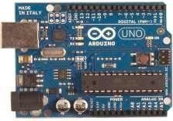

## 

## IR Sensor

An infrared sensor is an electronic device that emits in order to sense some aspects of the surroundings. An IR sensor can measure the heat of an object as well as detects the motion. These types of sensors measures only infrared radiation, rather than emitting it that is called as a passive IR sensor. 11 Usually in the infrared spectrum , all the objects radiate some form of thermal radiations. These types of radiations are invisible to our eyes that can be detected by an infrared sensor. The emitter is simply an IR LED (Light Emitting Diode) and the detector is simply an IR photodiode which is sensitive to IR light of the same wavelength as that emitted by the IR LED. When IR light falls on the photodiode, the resistances and these output voltages, change in proportion to the magnitude of the IR light received.

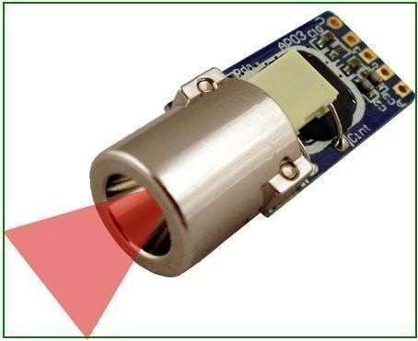

## IOT

Internet of things (IoT) is the network of devices such as vehicles, and home appliances that contain electronics, software, actuators, and connectivity which allows these things to connect, interact and exchange data. The IoT involves extending Internet connectivity beyond standard devices, such as desktops, laptops, smartphones and tablets, to any range of traditionally dumb or non internet enabled physical devices and everyday objects. Embedded with technology, these devices can communicate and interact over the Internet, and they can be remotely monitored and controlled.

## 

## LCD

LCD is used to display the results of the system operation such as sensed values, motor status etc. A liquid-crystal display (LCD) is a flat panel display, electronic visual display, or video display that uses the light modulating properties of liquid crystals. Liquid crystals do not emit light directly. The LCD standard requires 3 control lines and 8 I/O lines for the data bus. The interfacing with various microcontrollers, various interfaces (8-bit/4-bit), programming, special stuff and tricks. The most commonly used LCDs found in the market today are 1 Line, 2 Line or 4 Line LCDs which have only 1 controller and support at most of 80 characters, whereas LCDs supporting more than 80 characters make use of 2 HD44780controllers.

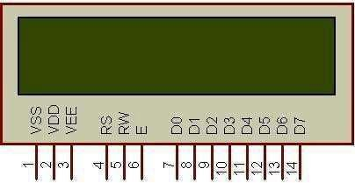

**WORKING OF PROJECT**

The transmitting side of the Ardunio Uno is connected to the receiving side of the IR sensor .The power supply is given to the Ardunio Uno. From the Ardunio Uno the power is distributed to all other components. Each component are connected and controlled by the Ardunio. By using MQTT client application we can receive the message. In upward motion, the bump are rises few centimeter above the road surface and give physical remainder to driver. The upward motion to the bumps is provides by various mechanism like Rack and Pinion mechanism, Scissor Jack mechanism. In downward motion, the bumps of smart speed breaker lower into the road surface production match in road surface thus giving physical remainder to driver. The downward motion of bump is provided by roller mechanism. Screw jack along with electric motor can be used to load lifting easier. The output is the turning on and off of the buzzer every other second. The picture below shows the setup of your module and Arduino. If the vehicle at the abnormal speed cross the speed breaker more than five times the license will be blocked and we will receive the warning message in third time of the same vehicle cross the speed breaker at abnormal speed.

**ADVANTAGES & CONCLUSION**

We proposed and implemented a Smart Speed breaker system, Smart speed breakers are the traffic claiming devices where over speeding vehicles will activate the speed breaker and it will rise the speed bumps above the surface of the road and will give the physical remainder to the driver for slowing down the vehicle. If the speed of the vehicle will be in the given allowed speed limit then the speed bumps will remain flat on the surface of the road and the vehicle can pass through it comfortably. In implementation we will be using an iron finished flat speed breaker which is skilled of rising with the help of control circuitry of embedded system. In this project we used an Arduino board and proximity sensors to detect the speed of vehicle and activate the speed.